Space Ship Commander

# Setting Up Visual Studio

Navigate to the URL: <https://www.visualstudio.com/en-us/products/visual-studio-community-vs.aspx> shown below.

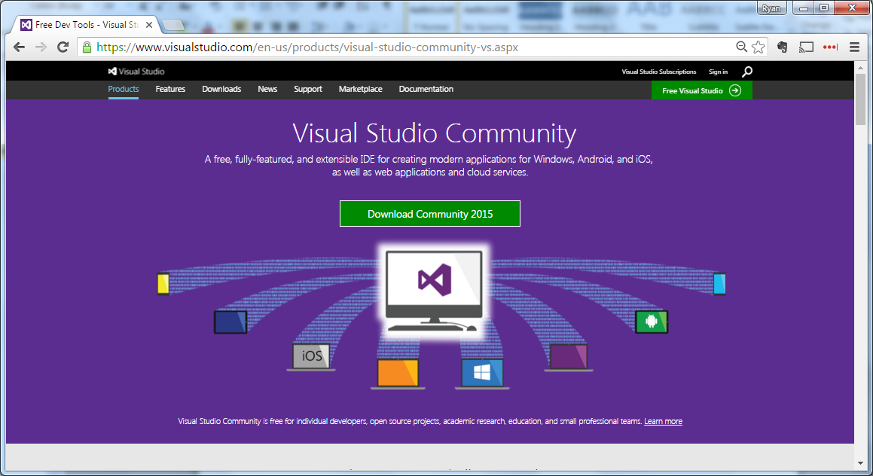

Click “Download Community 2015” and when download is complete run the installation program & follow all installation instructions.

# Getting the Game Files

Navigate the following link: <https://github.com/rkenning/SpaceshipCommander>

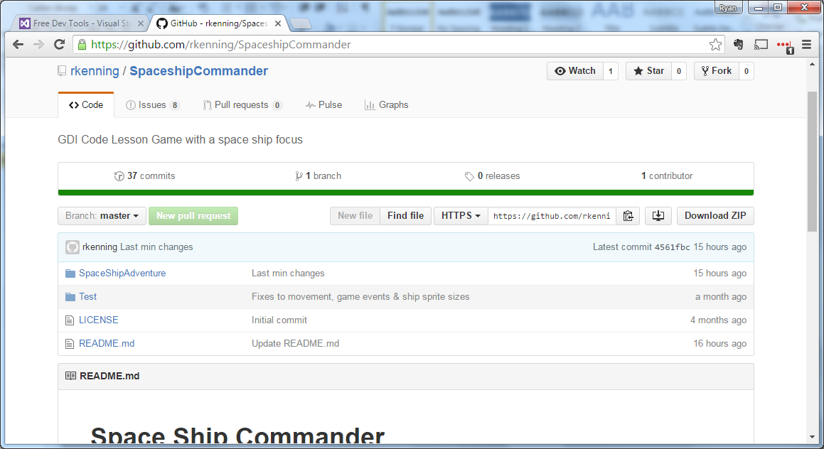

Select Download ZIP & open the zip when the download is complete. Copy the folder from the Zip file to a location on your hard drive e.g. My Documents (You will need to remember when you copy the folder too to open in Visual Studio)

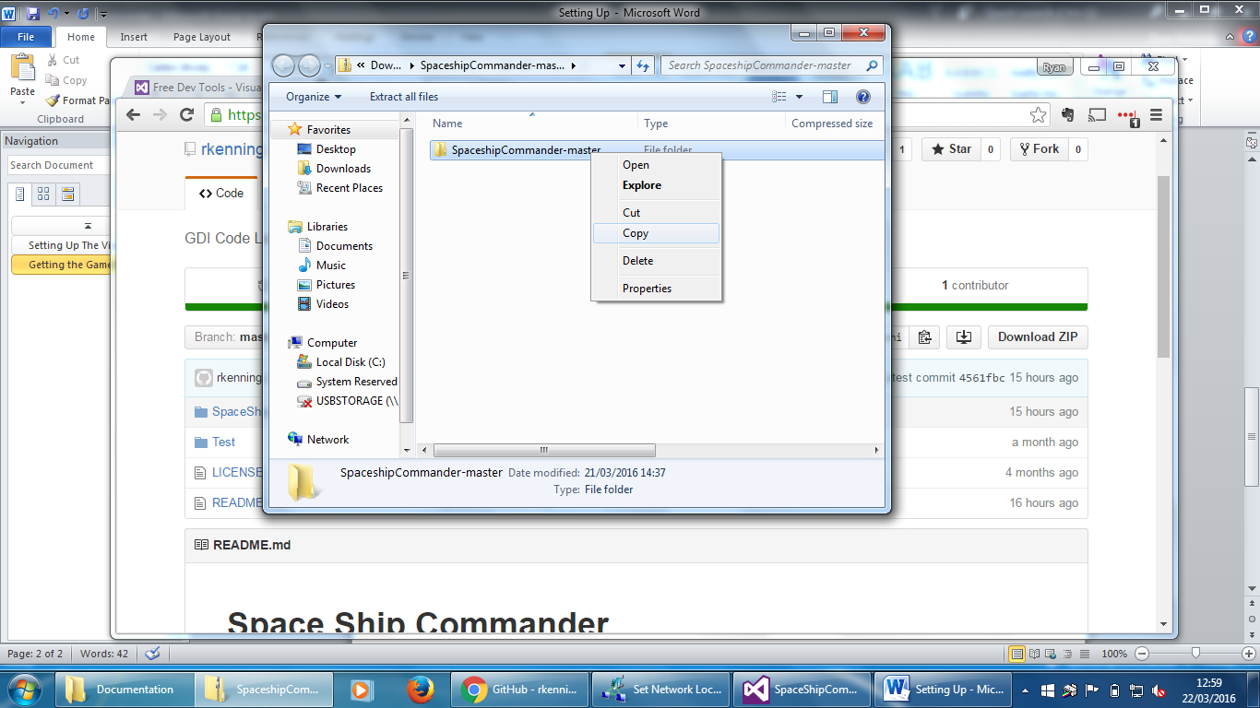

Open Visual Studio 2015 & select file open Project/Solution shown below:

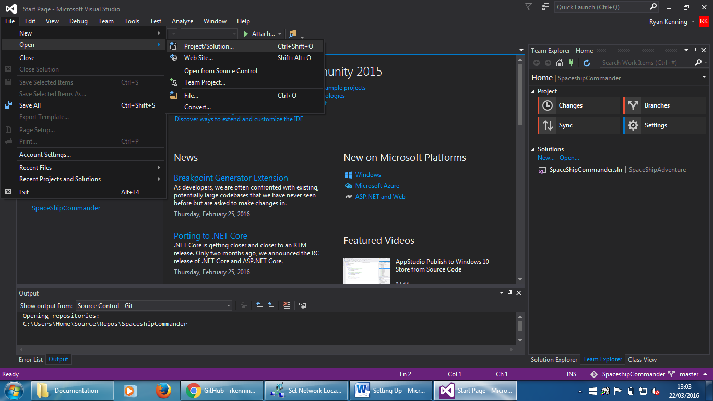

Navigate to the folder you copied to your Hard Drive.

Within the folder, open the sub folder named “SpaceShipAdventure”. You should now see the following screen:

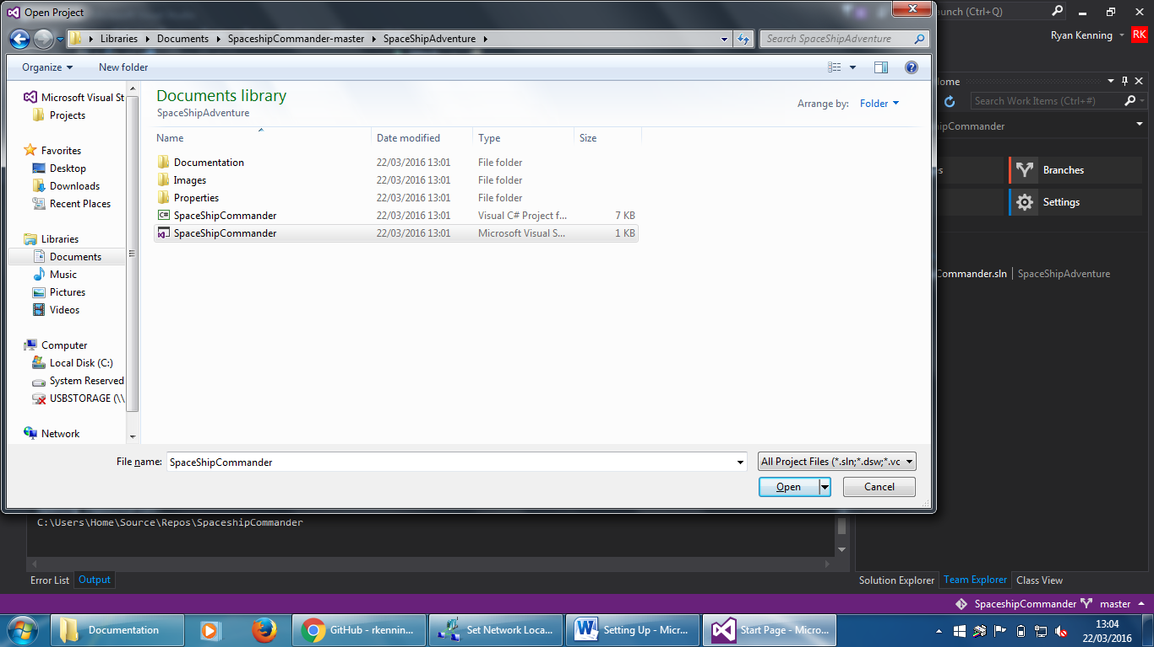

Select and open the file SpaceShipCommander (Microsoft Visual Studio Solution) shown as highlighted below:

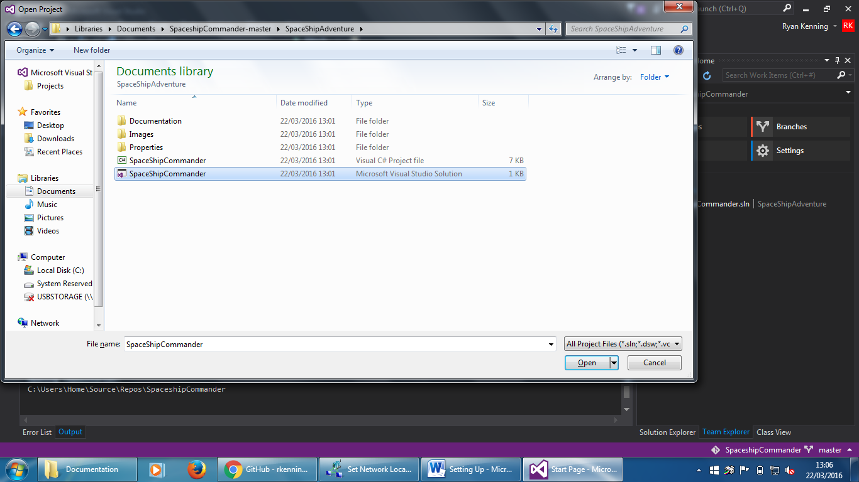

You may receive the following warning when opening the file for the first time:

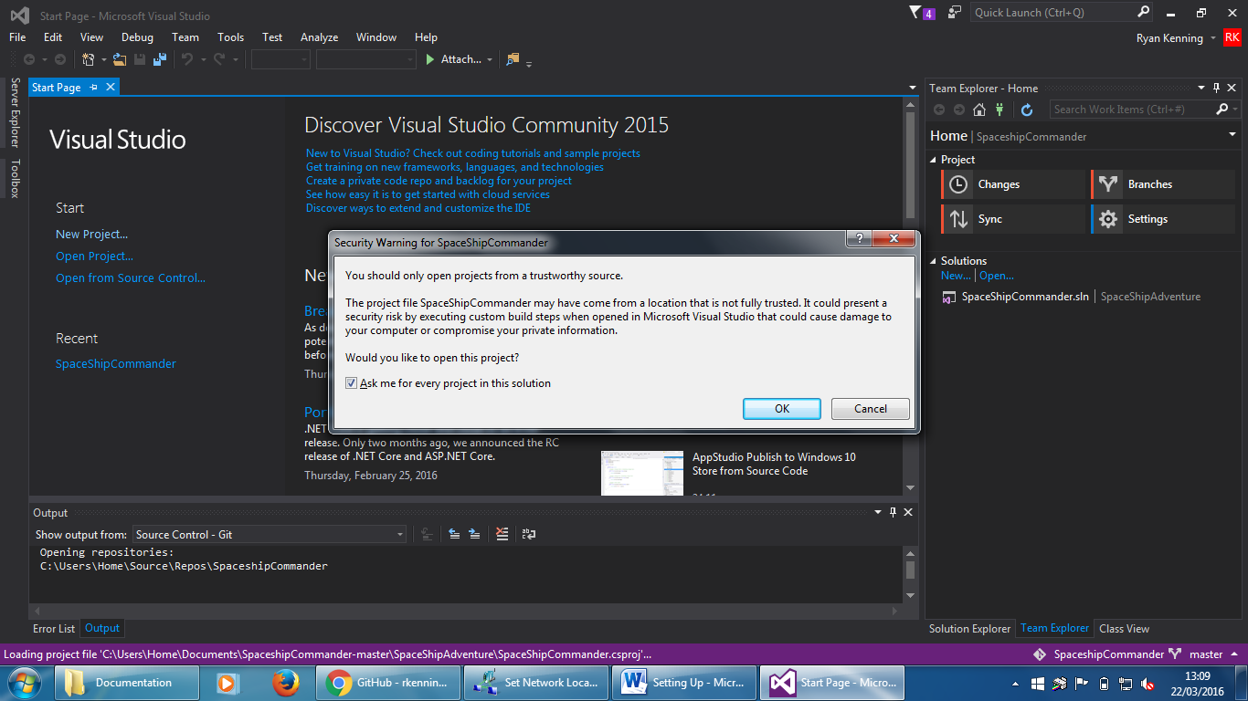

Click ok and continue to load the solution.

Once the solution has loaded you should see something similar to the following screen:

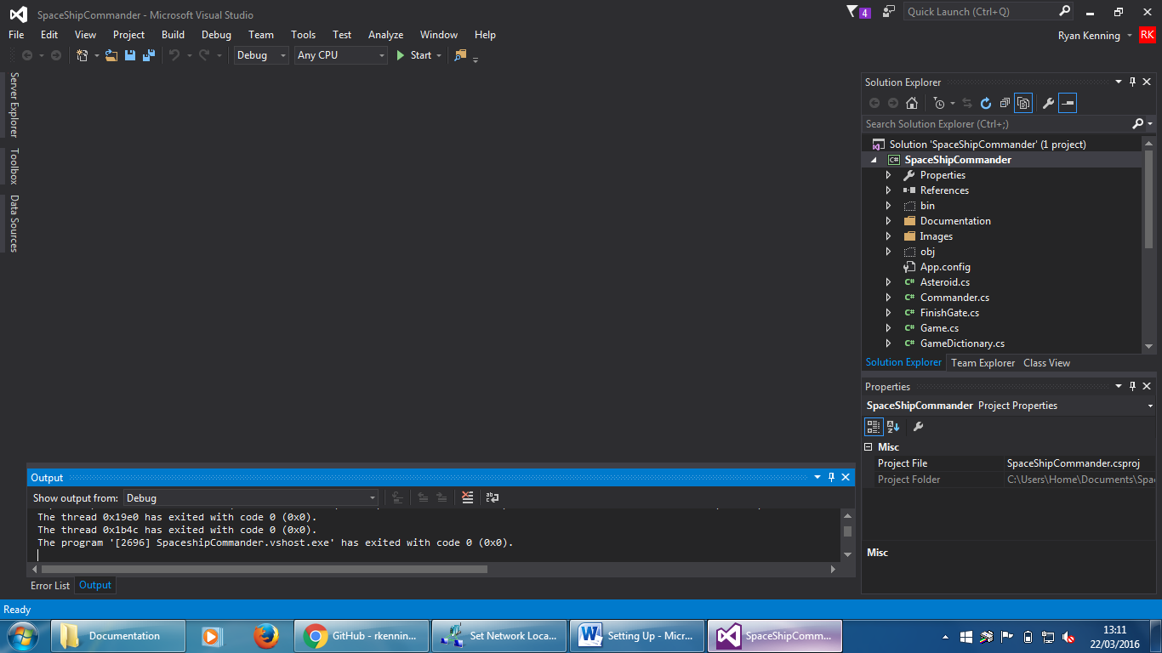

You are now ready to start coding!

# Running the GAME

Press F5 or click on the icon at the top of the screen:

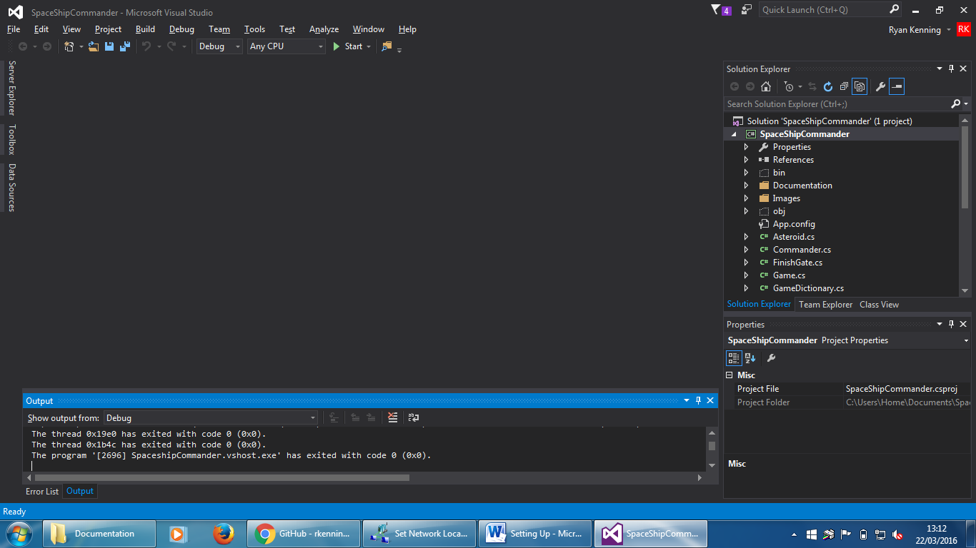

The Game Application will now build & start. After a few seconds the game area screen should pop up:

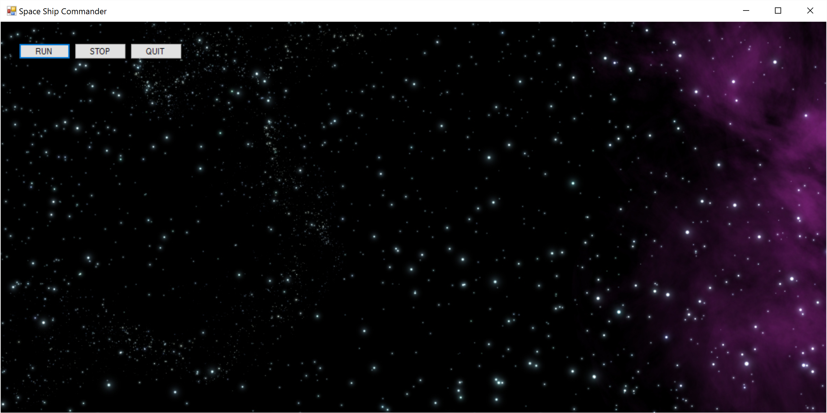

You are now ready to start Level 1!